Clustering Techniques
Task 1
Kiara Angelys Gänger
Western Governor University
D212 | Data Mining II

Scenario 1
One of the most critical factors in customer relationship management that directly affects a company’s long-term profitability is understanding the customers. When a company understands its customers’ characteristics, it is better able to target products and marketing campaigns for customers, resulting in better profits for the company in the long term.
You are an analyst for a telecommunications company that wants to better understand the characteristics of its customers. You have been asked to use clustering techniques to analyze customer data to identify groups of customers with similar characteristics, ultimately enabling better business and strategic decision-making.

Part I: Research Question

Purpose of Report

Question
What are the key customer segments based on monthly charges, tenure, and service usage, and how can these segments inform targeted marketing strategies?

Goal
My goal is to group customers into clusters based on variables that reflect account behavior and service usage. This will help stakeholders identify customer segments to improve targeted marketing strategies and service delivery.

Part II: Technique Justification

Reasons for Technique

Explain how k-means analyzes the data:
K-Means Clustering is an Unsupervised Machine Learning algorithm, which groups the unlabeled dataset into different clusters (K means Clustering – Introduction, 2024). It works by assigning each customer to one of k clusters, where k is the number of clusters you choose. The algorithm minimizes the variance within each cluster, making sure that customers in the same group are as similar to each other as possible based on the selected variables. The expected outcome is to be able to review a set of customer groups based on the input of the variables I will be using.

Assumption of k-means:
I want to clarify that K-means has two fundamental assumptions Spherical shape and isotropy and Equal Variance. For this section I will only be talking on one.
Spherical shape and isotropy this assumption means that K-means works best when the customer segments have clear, well-separated boundaries, because its relaying on the clusters being spherical and evenly distributed. If this is not met, this will cause the clusters to overlap.

Packages or Libraries
For this analysis, I will be using R. I will need the following:
- tidyverse
this will help with data preparation and manipulation
- factoextra
The purpose of this package is that it provides visualizations of the results. This will help with determining the optimal number of clusters and visualizing the cluster results
- cluster
The purpose of this package is that it provides clustering algorithms, including k-means. this will help with performing the actual clustering

Part III: Data Preparation

Perform Data Preparation

One data preprocessing goal:
One goal for this analysis is to ensure all continuous variables are scaled and free of outliers. This is important because for k-means, if variables like monthly charges and tenure are not standardized it can cause bias toward higher-value variables.

Identify Initial Variables
MonthlyCharge (continuous) | Tenure (continuous) | Bandwidth_GB_Year (continuous)

Steps to Prepare Data for Analysis
- Install the libraries
1. library(tidyverse)
2. library(factoextra)
3. library(cluster, lib.loc = "C:/Program Files/R/R-4.4.1/library")
- Load the data and inspect the data
- churn <- read.csv("C:/Users/Kiara/OneDrive/WGU MSDA/D212 Data Mining II/churn_clean.csv")
2. View(churn)
3. str(churn)
4. summary(churn)
- Select relevant variables
1. cluster_data <- churn %>%
2. select(Tenure, MonthlyCharge, Bandwidth_GB_Year) %>%
3. na.omit() # Remove rows with missing values
- Standardize the variables
1. cluster_data_scaled <- scale(cluster_data)
- Check for outliers
- boxplot(cluster_data)
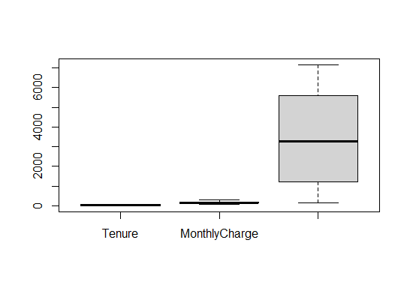
- Save the set for clustering
- write.csv(cluster_data_scaled, "C:/Users/Kiara/OneDrive/WGU MSDA/D212 Data Mining II/cleaned_cluster_data.csv", row.names = FALSE)
- View(cluster_data_scaled)

Part IV: Analysis

Perform the Data Analysis

Optimal Number of Clusters
To determine the optimal number of clusters I will use the Elbow Method
The Elbow Method helps to determine the number of clusters by plotting the within-cluster sum of squares (WSS) against the number of clusters (k). The "elbow" point indicates where the WSS starts decreasing slowly, suggesting the optimal number of clusters (Elbow Method for optimal value of k in KMeans, 2023).
- fviz_nbclust(cluster_data_scaled, kmeans, method = "wss") + labs(title = "Elbow Method for Optimal Clusters", x = "Number of Clusters (k)", y = "Total within-cluster sum of squares (WSS)")
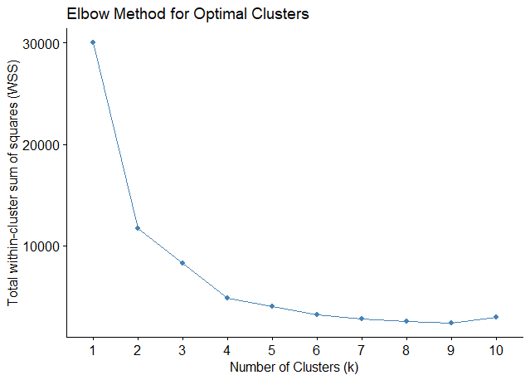

Cold used for Clustering Analysis
After running the code above and reviewing the chart I have determined that the optimal number of clusters is 4. Now I can proceed with the k-mean cluster. Here is the code used:
1. # Perform k-means clustering with 4 clusters
2. set.seed(123) # For reproducibility
3. kmeans_result <- kmeans(cluster_data_scaled, centers = 4, nstart = 25)
4.
5. # View the cluster centers
6. kmeans_result$centers
7.
8. # View the number of observations in each cluster
9. kmeans_result$size
10. # Calculate and print the total within-cluster sum of squares (WCSS)
11. wcss <- kmeans_result$tot.withinss
12. print(paste("The total within-cluster sum of squares (WCSS):", wcss))

Part V: Data Summary and Implications

Summary of data analysis

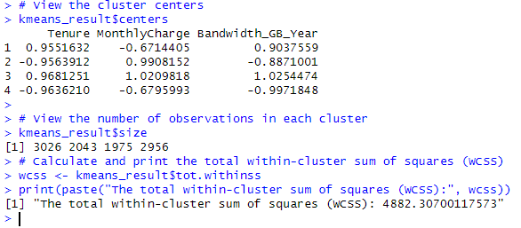

Explanation of cluster quality:
The clusters that were created are well-defined given that k-means clustering aims to minimize the variance within each cluster. The within-cluster sum of squares WCSS shows that the clustering was effective and accurate. The total WCSS for the 4 clusters is 4882.31, indicating the combined variance within each group. The separation of customer segments by the variables Tenure, MonthlyCharge, and Bandwidth_GB_Year indicates distinct groupings of customers based on their usage patterns. The clusters are relatively balanced in size, with no extreme discrepancies between the number of observations in each cluster. This means that the segmentation successfully captures meaningful differences between customer groups.

Discuss the Results and Implications of Your Clustering Analysis:
The 4 clustering results
- Cluster 1: made up of 3026 customers has Long-tenured(0.9551632), high-bandwidth(0.9037559) users with relatively low monthly charges(-0.6714405). This segment is likely to be made up of loyal customers who are getting good value for their service and might be ideal candidates for rewards or loyalty programs to ensure continued retention.
- Cluster 2: made up of 2043 customers has Short-tenured(-0.9563912), high-paying(0.9908152) customers with low bandwidth(-0.8871001) usage. This segment is more than likely newer customers who are still adjusting to their services. Upselling opportunities may exist, particularly for services like internet usage upgrades.
- Cluster 3: made up of 1975 customers has Long-tenured(0.9681251), high-paying(1.0209818) customers with high bandwidth1.0254474) usage. This segment includes users who are likely high-value customers. These customers could be a focus for VIP services or premium packages, ensuring they remain satisfied.
- Cluster 4: made up of 2956 customers has Short-tenured(-0.9636210), low-paying(-0.6795993), and low bandwidth(-0.9971848) users. This group could represent customers at risk of churn. They are not as engaged with the services, and churn prevention strategies like offering personalized service recommendations or discounts could help retain them.
These insights allow for more targeted marketing strategies. For example, Cluster 1 may benefit from retention programs, while Cluster 4 could benefit from more aggressive retention efforts, such as discounts or tailored offers.

One Limitation of Your Data Analysis:
One limitation of my analysis is that I only used the continuous variables Tenure, MonthlyCharge, and Bandwidth_GB_Year. While these variables provide a clear understanding of customer behaviors related to their service usage, I did not incorporate categorical variables like Phone or StreamingTV, which might provide additional context. By including categorical variables through different clustering techniques or one-hot encoding might provide an even more detailed customer segment.

Recommended Course of Action
Based on my question “What are the key customer segments based on monthly charges, tenure, and service usage, and how can these segments inform targeted marketing strategies?” I would recommend the following targeted marketing strategies:
- Cluster 1 (Loyal customers): Implement loyalty and retention programs. Offering rewards or discounts for long-term customers can help solidify their relationship with the company and make them feel valued.
- Cluster 2 (High-paying, low-usage customers): Focus on upselling and cross-selling. Offering services that increase engagement, such as personalized packages for higher internet usage, could increase satisfaction and revenue.
- Cluster 3 (Premium customers): Create VIP experiences. These customers should be given high-priority service or exclusive offers to keep them engaged and satisfied.
- Cluster 4 (At-risk customers): Implement churn prevention strategies. Like personalized outreach programs, discounts, or service enhancements that could prevent churn and improve engagement.

Part VI: Demonstration

Panopto Video Recording
Link: Ganger, Kiara Task 1 D212 (panopto.com)

References
Elbow Method for optimal value of k in KMeans. (2023, May 10). Retrieved from geeksforgeeks: https://www.geeksforgeeks.org/elbow-method-for-optimal-value-of-k-in-kmeans/
K means Clustering – Introduction. (2024, August 29). Retrieved from geeksforgeeks: https://www.geeksforgeeks.org/k-means-clustering-introduction/

